**Week 4**

1. Given a linked list, swap every two adjacent nodes and return its head. You must solve the problem without modifying the values in the list's nodes (i.e., only nodes themselves may be changed.)
2. 2. Given the head of a linked list and a value x, partition it such that all nodes **less than** x come before nodes **greater than or equal** to x.

You should **preserve** the original relative order of the nodes in each of the two partitions.

**Example 1:**

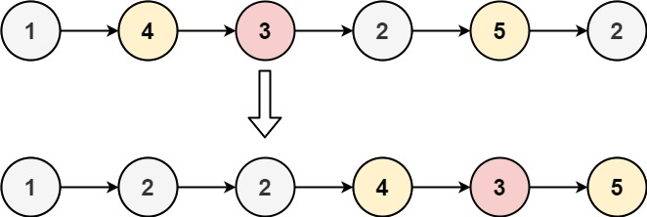

1. Given the head of a linked list, remove the nth node from the end of the list and return its head.

